Roan School
1116 Roan Street /Dalton, GA 30721 /706-876-4350
roan.daltonpublicschools.com
2016-17 Schoolwide Title 1 Plan
______________________________________________________________________________
Una traduccion de este documento esta disponible en nuesta escuela.
Llame al 706-876-4350
Revised: 8-29-26, 9-7-16, 9-15,16, 9-26-16, 10-6-16
Parent/Community Review: 9-27-16, 10-14-16
Parent/community Suggestions/Amendments: 10-4-16
Any Second Revisions Incorporating Suggestions/Amendments: 10-7-16
Last Call for Suggestions/Amendments: 10-8-16, 10-18-16
Final Update for 2016-2017: 10-19-16

Table of Contents

Introduction 2

1. Comprehensive Needs Assessment 5

2. School wide Strategies for Reform 25

3. Highly Qualified Instructional Staff 31

4. Professional Learning 32

5. Strategies to Attract High Quality Teachers to High Needs Schools 34

6. Strategies to Increase Parent Involvement 35

7. Transition Plans for Students 39

8. Measures to Include Teachers in Decision-Making 40

9. Effective and Timely Assistance 41

10. Coordination of Federal, State, and Local Programs 43

11. Interpretation to Parents 45

12. Assessment Results/Collection and Disaggregation of Data 46

13. Valid and Reliable Disaggregated Results 47

14. Public Reporting 48

15. Plan Development Period 49

16. Community Involvement in Plan 50

17. Plan Availability 51

18. Plan Translation 52

19. Section 1116 Provision 53

Introduction

The history of Roan's ethnic population has shown a dramatic shift from predominately Anglo and African-American students to a majority of Hispanic children. This shift occurred over a three year period in the 1990's and maintains that status today, although the rate of change has decreased. Our school is located in a zone with a high number of rental homes and government subsidized apartment buildings. Many families who move to our community or are new to the United States first move into these rental facilities in Roan's school zone.
The Dalton community is known as the "Carpet Capital of the World", therefore out of the various services, industry, manufacturing and retail businesses, it is no wonder that the highest occupation listed for Dalton residents is production worker (33%). Most of our students' parents fall into this category. The average income per capita in 1989 was $15,284, in 1999 it was $20,575, and in 2014 it was $20,451. The Dalton community, like many other communities in the United States, has experienced hardships due to the high unemployment rates. In April 2015, Dalton had an unemployment rate of 7.2%. This rate is 2.3% higher than the nation unemployment rate of 4.9%. The data below shows the racial demographics of the city of Dalton.

Dalton, GA: Population by race - Census 2010
Population - 33,128

White alone 65.05%
Black 6.36%
Asian 2.35%
2 or more races 3.23%
American Indian 0.64%
Native Hawaiian .13%
Other 22.24%

Persons Not of Hispanic or Latino Origin 52.03%
Persons of Hispanic or Latino Origin 47.97%
Source: www.censusviewer.com

Roan School is one of six elementary schools in the district and is located in the northeast section of Dalton Public Schools. The school was opened in March of 1969 with additions in 1995 and 2003. The school currently educates 487 students in Pre-Kindergarten through fifth grade. Nearly 45% of our students are English learners, acquiring English and subject-area content simultaneously. The data below demonstrates the shifts in demographics and the stability of the free/reduced percentages for the school

Roan School Free and Reduced Lunch From 2000-2016

Total # Students #Free #Reduced Total % F/R
2013-2014 522 388 72 88.12
2014-2015 503 382 73 87.7
2015-2016 478 280 13 61.30
2016-2017 487 363 65 88.4

Roan School Racial Demographics 1990-2016

Asian Am. Indian Hispanic Black White Multi Racial Other
1990 14.0% 24.0% 61.0% 1%
2013 84.7% 5.2% 8.4% 1.7%
2014 85.7% 4.3% 8% 2%
2015 86.4% 5.6% 6% 2%
2016 87.8% 4.5% 6.3% 1.4%

Roan School has a staff of 72 that provides a warm, nurturing, and safe learning environment for the Roan School community. Certified staff members include 2 administrators, 21 certified classroom teachers, 20 certified support teachers, 1 media specialist, 1 counselor, 1 social worker, 1 transition coach, and 1 technology assistant. Our classified support staff includes 12 paraprofessionals, 1 nurse, 2 secretaries, 3 custodians, and 6 cafeteria personnel that also support the students and staff. The data below shows the racial demographics for staff at Roan School.

Roan School Staff Demographics by Race 2014-2016

Caucasian 78%
Hispanic 22%
Roan School, a proud member of the Dalton Public Schools team, adopts and acts upon the beliefs and vision of the district. We believe that each student is unique and can learn more at higher levels. We believe students give their attention and commitment when provided engaging experiences. We believe literacy is fundamental for success in all pursuits and necessary for lifelong learning. We believe together, we achieve more. We believe each individual is a learner, teacher, designer, and leader. We believe education is essential to the well-being of each individual, the economy and our democratic way of life. We aspire to a vision where each student of Dalton Public Schools engages in interesting, challenging, and satisfying experiences that result in profound learning in academic disciplines, synthesis, creativity, respect, and ethics so that each student is a contributing citizen of the world.
Therefore, it our mission at Roan to:
- Prepare students to compete and lead in a global work environment
- Recognize and embrace the diversity of each learner
- Instill mutual respect, accountability, ethics, and compassion for others
- Design student work that results in authentic learning
- Engage students with ever changing 21st century technologies.

Several changes have impacted the literacy program at Roan School in the last decade. Most recently, since 2004, the Literacy Collaborative framework was adopted district-wide and a phase-in implementation took place across the grade levels. Over the years teachers have learned more about the reading and writing process and are able to instruct their students in a more individualized way. Through Literacy Collaborative teachers have learned to analyze literacy data which has enabled them to make instructional decisions that will impact students the most. Individual conferencing shows deeper understandings of the connection between reader and writer. The LC framework is enhanced and supported through the inclusion of Reading Recovery instruction, Leveled Literacy Intervention and Literacy Lessons for ESS students.
Roan will use Title 1 resources to provide quality, engaging work for all students. Funds will be used to secure appropriate tools, materials, and expertise that will enhance and support the core content areas using Reading Recovery and Literacy Collaborative Coaches, specifically Science, Technology, Engineering and Math (STEM/iLab) within the learning day. Additionally, Title I dollars will be used to increase parent involvement. Funds provided by Title I, as well as state and local monies, will be used to support the programs that serve all our students, including those who need EIP, ESS, and ELL services.
Teachers will use a variety of available resources to meet state standards in all content areas. Teachers work closely together to collaborate around tough-to-teach concepts as identified through ongoing analysis of quarterly, common assessments in each grade level. Additionally, instruction in Art, Music, and P.E. is offered to all students by fulltime certified instructors. The Guidance Counselor provides classroom lessons on a variety of themes, as well as small groups that focus on counseling topics. iLab provides students with additional opportunities to be engaged in Science, Technology, Engineering and Math as supported by 2 iLab classified paras. Reading Recovery, Leveled Literacy Intervention, Literacy Lessons, Early Intervention Program, English Language Learners, Exceptional Student Services, and Challenge services will also be provided for students who qualify. Migrant students will be identified and tutorial services provided as needed.
Roan School is currently working under a well-defined instructional plan which drives all decisions, including the expenditure of funds. Under, NCLB, Roan met adequate yearly progress for 13 consecutive years and received a Georgia Title 1 Distinguished School award for 11 consecutive years.

- Comprehensive Needs Assessment

- We have developed our schoolwide plan with the participation of individuals who will carry out the comprehensive schoolwide/school improvement program plan. Those persons involved are:

- Roan School Design Team Members: Cindy Parrott (Principal), Charlie Tripp (AP), Laurie Swanson (Reading Recovery and Co-Chair), Holly Williams (Intermediate Literacy Coach), Jamie Lou Phillips, (K teacher), Randi Grant (EIP support), Amy Sherman (5th grade teacher), Ashley Edwards (Reading Recovery/EIP,ELL), Jessica Smith (Primary Literacy Coach), and Carol Farrow (4th grade teacher)

- Roan School Evidence and Assessment Team (EAT) Members: Cindy Parrott (Principal), Charlie Tripp (AP), Holly Williams (co-chair and Intermediate Literacy Coach), Carol Farrow (4th grade teacher), Tiffany Martin (EIP/ELL support), Sally Partlo (ESS), Jessica Smith (Primary Literacy Coach), Brooke Halverson (1st grade teacher), Amanda Hisle ( 2nd grade teacher), Natalie Dixon (Bridges/Challenge teacher), and Shauna Sanders ( Media/Technology Specialist)

- Roan School Council Members: Jose Fraire (Council Chairperson-Parent), Zab Mendez (Co Chair- Parent), Tyree Goodlett(Parent), Maria Carrillo (Parent), Amy Sherman (Secretary- 5th grade teacher), Margaret Kolbas (4th grade teacher), and Cindy Parrott (Principal)

- School Administration Team: Cindy Parrott (Principal) and Charlie Tripp (Assistant Principal)

The ways they were involved were in analyzing data from all data sources regularly, redesigning instruction, coaching teachers, providing feedback, brainstorming and increasing resources/opportunities.

Our Evidence and Assessment Team collected all assessment data and presented it for analysis. The data analysis for needs assessment was completed by school teams. An opportunity for feedback was provided.

- We have used the following instruments, procedures, or processes to obtain this information:

- Georgia Criterion Reference Competency Test (Georgia Milestones, 3rd-5th grades)
- ACCESS (ELL)
- Schoolwide Writing Performance (all grades)
- Literacy Collaborative Observational Surveys and Running Records
- Individual Guided Reading Levels
- Student Survey 3rd – 5th
- Parent Survey Data
- Staff Survey Data
- IXL Data
- Demographic Data
- Attendance Data
- ESS Progress Monitoring Data
- Reading Recovery Data
- Leveled Literacy Intervention Data
- Response to Intervention Data
- Weekly collaboration from all classroom teachers
- GKIDS
- Guided Reading Levels
- GloSS

- We have taken into account the needs of migrant children. DPS offers one on one tutoring, pay for immunizations, eye exams and glasses. The migrant coordinator, Annette Nietzsche, translates at school meetings when asked by either the parent or teacher. She put them in contact with community resources to meet other needs such as Medicaid/Medicare, WIC, English and computer classes. We have 1 migrant student this year.

- We have reflected current achievement data that will help the school understand the subjects and skills in which teaching and learning need to be improved. Roan utilizes the Common Core Georgia Performance Standards as the model for instruction. Administrators and teachers examine and discuss multiple, disaggregated measures of data including demographic and perceptual data and data regarding student learning and school processes.

The following charts depict our school’s performance on the CRCT for the previous three years in the core content areas and our latest Georgia Milestones data for 2015 and 2016. Direct comparisons cannot be made from CRCT to Milestones due to the nature of the test, rigor and constructed and extended writing responses.

 | Math |  | % Meeting/Exceeding Standard on CRCT
 | Dalton All Students | Roan  All Students | Black | White | Hispanic | Asian | American Indian | Multi-racial | SWD | LEP | Econ  Disadv
2011-2012 | 83 | 83 | 85 | 60 | 90 | N/A | N/A | N/A | 33 | 72 | 83
2012-2013 | 85 | 81 | 100 | 40 | 88 | N/A | N/A | 50 | 35 | 77 | 82
2013-2014 | 81 | 77 | 67 | 63 | 79 | N/A | N/A | 75 | 30 | 58 | 78

*Our 2013-2014 data shows that our overall population performed comparably with our district and state. Our Hispanic population, which represents 85.7% of our total population, and the ED population performed at higher levels than our other ethnic groups. Five out of seven performed lower in 2013-2014 than in 2012-2013. The achievement gap is with SWD and Hispanic subgroups.

Georgia Milestones  2014-2015 | Math |  |  | % Students Proficient (Levels 3 & 4)
 | Dalton  All Students | Roan  All Students | Black | White | Hispanic | Asian | American Indian | Multi-  racial | SWD | LEP | Female | Male
3rd grade | 30 | 18 | Only 3 students | Only 5 students | 17 |  |  |  | Only 7 students | 5 | 23 | 15
4th grade | 30 | 32 | Only 7 students | Only 6 students | 34 |  |  | Only 2 students | Only 3 students | 57 | 37 | 29
5th grade | 31 | 14 | Only 2 students | Only 3 students | 14 |  |  | Only 2 students | 0 | 10 | 19 | 10

*The baseline data shows that 3rd and 5th grade in Math at Roan were below the district average of proficient students. 68% of the district in math were below grade level in math. 82% of 3rd graders in Math at Roan were level 2 or below (which is below grade level). 68% of 4th graders in math at Roan were Level 2 or below (below grade level) 86% of 5th graders in math at Roan were Level 2 or below. By 5th grade, the system is 69% below grade level. By 5th grade, the state of Georgia is 61% below grade level

 | Georgia Milestones | Math |  | % of Proficient and Distinguished (Levels 3 and 4)
 |  | Dalton  All Students | Roan  All Students | Black | White | Hispanic | Multi-  racial | SWD | ELL | ED | Female | Male
 | 2015 | 28% | 18% | 27% | 16% | 21% |  | 0% | 6% | 21% | 26% | 19%
 | 2016 | 29% | 31% | 0% | 23% | 25% |  | 7% | 10% | 24% | 24% | 24%
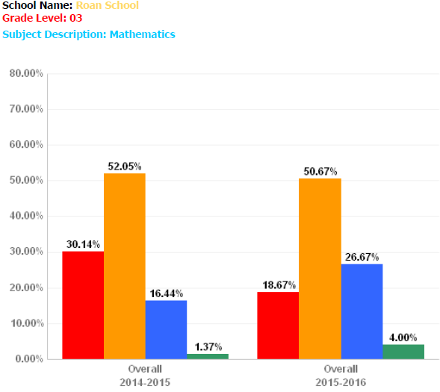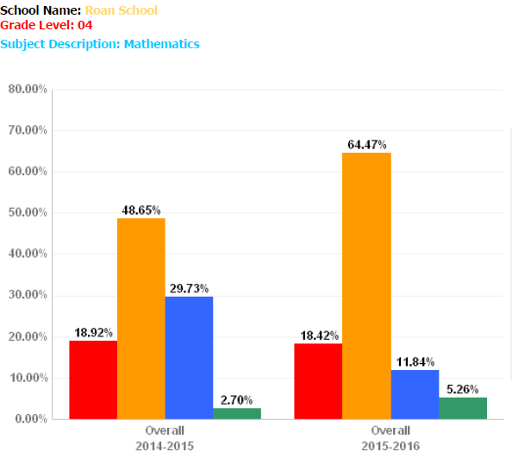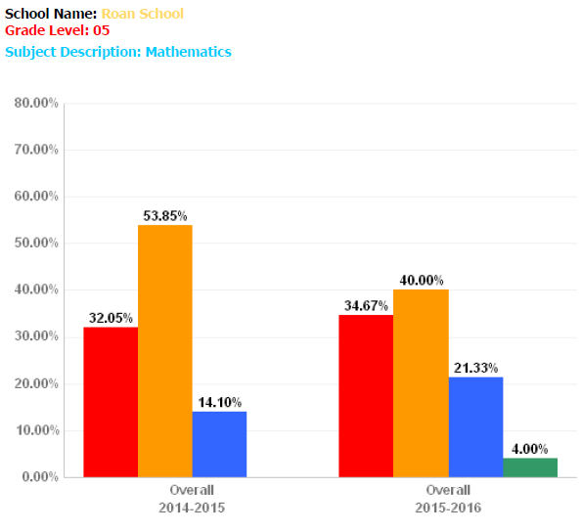
Roan School’s overall percentage of students who were proficient or distinguished students grew by two percent. Six out of the eight subgroups improved for the 2016 school year. Among these groups, white students and students with disabilities showed the most gains. The decrease from 27 percent to zero percent of African American subgroup indicates a need to investigate further about the shift. Also meriting investigation is the decrease in percent of proficient and distinguished female subgroup.

 | Reading |  | % Meeting/Exceeding Standard on CRCT
 | Dalton  All Students | Roan  All Students | Black | White | Hispanic | Asian | American Indian | Multi-racial | SWD | LEP | Econ  Disadv
2011-2012 | 92 | 90 | 86 | 80 | 91 | N/A | N/A | N/A | 50 | 68 | 90
2012-2013 | 93 | 86 | 100 | 66 | 86 | NA | N/A | 100 | 43 | 80 | 85
2013-2014 | 95 | 92 | 75 | 91 | 92 | N/A | N/A | 100 | 61 | 86 | 91

A strength for Roan School is that five out of seven subgroups improved for 13-14 school year. Among, these subgroups, white students and students with disabilities showed the most gains. The data indicates that we need to investigate our African American subgroup to determine how to make an achievement shift in these groups that represent 4.3% of our population. The greatest achievement gap is between SWD and Hispanic population.

 | Georgia Milestones  2015 | Reading  % of students on grade level or above
 |  | Dalton  All Students | Roan  All Students
 | 3rd grade | 63% | 41%
 | 4th grade | 52% | 47%
 | 5th grade | 62% | 44%

*3rd grade students scored an average of 22% below the district and 28% below the state in the area reading and vocabulary at grade level or above. 4th grade students scored an average of 5% below the district and 12% below the state in the area of reading and vocabulary at grade level or above. 5th grade students scored an average of 18% below the district and 22% below the state in the area of reading and vocabulary at grade level or above.

 | Georgia Milestones  2016 | Reading  % of students on grade level or above
 |  | Dalton  All Students | Roan  All Students
 | 3rd grade | 60% | 55%
 | 4th grade | 48% | 34%
 | 5th grade | 55% | 58%

3rd grade students scored an average of 5% below the district which is an increase of 14% from 2015. 4th grade students scored an average of 14% below the district and 5th grade students scored an average of 3% above the district average. There is a discrepancy between 2015 and 2016 4th grade percentages. This warrants a deeper analysis of the decline in 4th grade of students reading on or above grade level.

 | ELA |  | % Meeting/Exceeding Standard on CRCT
 | System All Students | Roan  All Students | Black | White | Hispanic | Asian | American Indian | Multi-racial | SWD | LEP | Econ  Disadv
2011- 2012 | 93 | 89 | 85 | 70 | 90 | N/A | N/A | N/A | 47 | 69 | 89
2012-2013 | 92 | 86 | 100 | 47 | 88 | N/A | N/A | 100 | 39 | 81 | 87
2013-2014 | 92 | 87 | 75 | 92 | 87 | N/A | N/A | 100 | 55 | 76 | 87

White students almost doubled this past year. However, this is only 8% of our population. Roan School students are slightly below the system average and the state target. The students with disabilities subgroup was the lowest overall but did make a gain of 16%. The greatest achievement gap is between SWD and White subgroups

Georgia Milestones  2014-2015 | ELA |  |  | % Students Proficient (Levels 3 & 4)
 | Dalton  All Students | Roan  All Students | Black | White | Hispanic | Asian | American Indian | Multi-  racial | SWD | LEP | Female | Male
3rd grade | 24 | 14 | Only 3 students | Only 5 students | 14 |  |  |  | Only 8 students | 0 | 19 | 11
4th grade | 29 | 23 | Only 7 students | Only 6 students | 24 |  |  | Only 2 students | Only 3 students | 38 | 34 | 15
5th grade | 31 | 10 | Only 2 students | Only 3 students | 11 |  |  | Only 2 students | 0 | 10 | 14 | 7

*The baseline data shows…. 3rd grade students scored 10% below the district and 23% below the state average in the area of English Language Arts @ a proficient level. 4th grade students scored 6% below the district and 14% below the state average in the area of English Language Arts @ a proficient level. 5th grade students scored 21% below the district and 29% below the state average in the area of English Language Arts @ a proficient level.

 | Georgia Milestones | ELA |  |  | % of Proficient and Distinguished (Levels 3 and 4)
 |  | Dalton  All Students | Roan  All Students | Black | White | Hispanic | SWD | ELL | ED | Female | Male
 | 2015 | 29% | 16% | 18% | 8% | 16% | 0% | 1% | 16% | 21% | 11%
 | 2016 | 29% | 21% | 13% | 8% | 22% | 0% | 5% | 21% | 28% | 15%
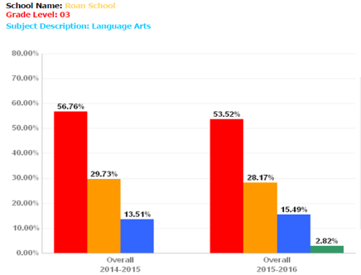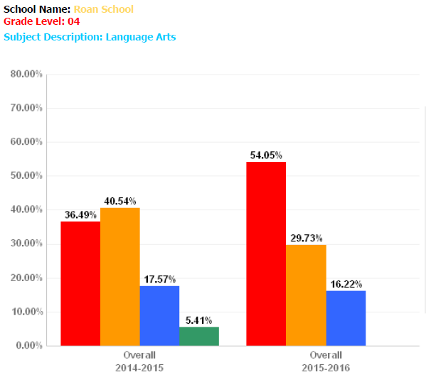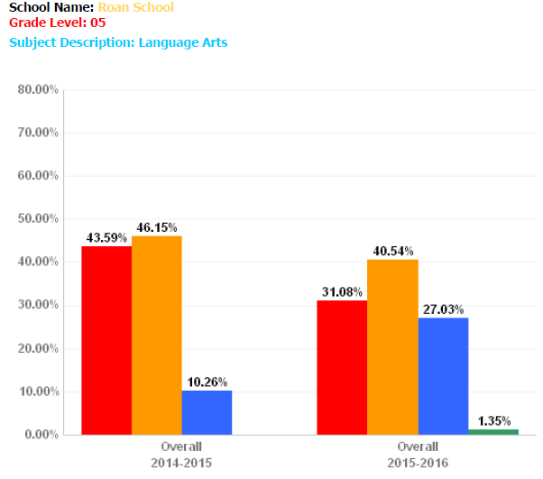
The 2016 data shows an increase of 5% of students Proficient and Distinguished in ELA. While Roan School remains below the district average our students are beginning to close the gap from 13% in 2015 to 8% in 2016
 | Science |  | % Meeting/Exceeding Standard on CRCT
 | Dalton All Students | Roan  All Students | Black | White | Hispanic | Asian | American Indian | Multi-racial | SWD | LEP | Econ  Disadv
2011-2012 | 73 | 63 | 57 | 50 | 64 | N/A | N/A | N/A | 23 | 32 | 63
2012-2013 | 75 | 59 | 100 | 33 | 59 | N/A | N/A | 67 | 20 | 42 | 60
2013-2014 | 71 | 74 | 69 | 64 | 75 | N/A | N/A | 50 | 37 | 53 | 75

Roan School exceeded the district average. Roan School’s English Learners and Students with Disabilities scored significantly lower than the overall state target. The greatest achievement gap occurred between the LEP, SWD and Hispanic population

Georgia Milestones  2014-2015 | Science |  |  | % Students Proficient (Levels 3 & 4)
 | Dalton  All Students | Roan  All Students | Black | White | Hispanic | Asian | American Indian | Multi-  racial | SWD | LEP | Female | Male
3rd grade | 21 | 12 | Only 3 students | Only 5 students | 13 |  |  |  | Only 7 students | 0 | 19 | 9
4th grade | 18 | 19 | Only 7 students | Only 6 students | 18 |  |  | Only 2 students | Only 3 students | 32 | 21 | 18
5th grade | 28 | 13 | Only 2 students | Only 3 students | 11 |  |  | Only 2 students | 0 | 10 | 14 | 12

*The Science baseline data for Roan School 3rd -5th grades shows that Roan percentages are lower than DPS and State percentages in 3rd and 5th grades. Fourth grade students scored one percent higher than the DPS and State percentages. DPS percentages were the same as the state percentages in Science in 3rd -5th grades. In all grade levels at Roan, female percentages were higher than males. In 3rd and 5th grades, Roan LEP student’s percentages were lower than the DPS and State percentages. Roan 4th grade LEP percentages were higher than the DPS and state percentages. Eighty-eight percent of Roan students are not proficient in science.

 | Georgia Milestones | Science |  |  | % of Proficient and Distinguished (Levels 3 and 4)
 |  | Dalton  All Students | Roan  All Students | Black | White | Hispanic | SWD | ELL | ED | Female | Male
 | 2015 | 22% | 15% | 27% | 8% | 15% | 0% | 1% | 15% | 17% | 14%
 | 2016 | 23% | 19% | 13% | 31% | 17% | 4% | 2% | 18% | 16% | 20%

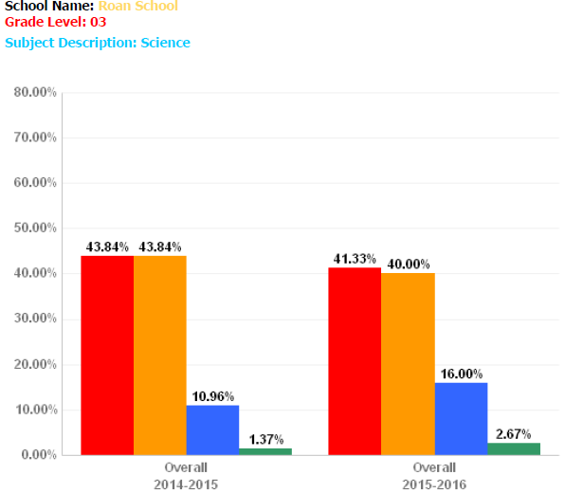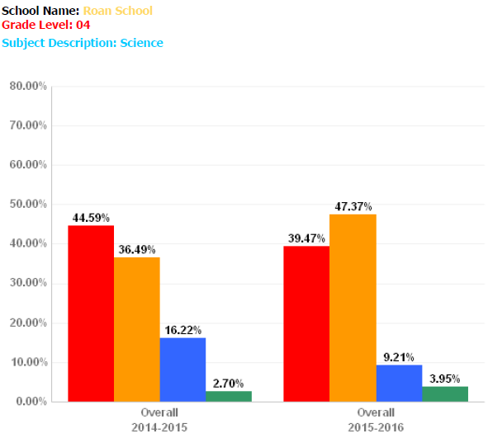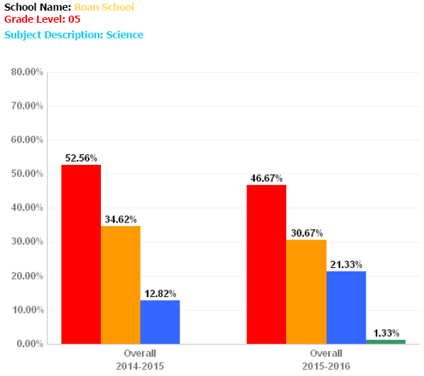
Roan School scored higher in 6 out of 8 subgroups compared to the 2014-2015 school year. Roan School’s African American population and Female subgroups were the only subgroups to decrease in 2015-2016. Roan School’s subgroup with the greatest increase occurred with the White subgroup.

 | Social Studies |  | % Meeting/Exceeding Standard on CRCT
 | Dalton All Students | Roan  All Students | Black | White | Hispanic | Asian | American Indian | Multi-racial | SWD | LEP | Econ  Disadv
2011-2012 | 77 | 71 | 71 | 60 | 71 | N/A | N/A | N/A | 39 | 44 | 71
2012-2013 | 82 | 74 | 100 | 40 | 77 | N/A | N/A | 50 | 24 | 68 | 76
2013-2014 | 84 | 82 | 70 | 71 | 83 | N/A | N/A | 75 | 45 | 69 | 82

Roan School scored higher in six out of seven subgroups in 2013-2014 compared to the 2012-2013 school year. Roan School’s African American population was the only subgroup to decrease in 2013-2014. Roan School’s greatest achievement gap occurred between the SWD and Hispanic subgroups.

Georgia Milestones  2014-2015 | Social Studies |  |  | % Students Proficient (Levels 3 & 4)
 | Dalton  All Students | Roan  All Students | Black | White | Hispanic | Asian | American Indian | Multi-  racial | SWD | LEP | Female | Male
3rd grade | 18 | 8 | Only 3 students | Only 5 students | 10 |  |  |  | Only 7 students | 0 | 16 | 4
4th grade | 24 | 22 | Only 7 students | Only 6 students | 24 |  |  | Only 2 students | Only 3 students | 39 | 24 | 20
5th grade | 26 | 6 | Only 2 students | Only 2 students | 6 |  |  | Only 2 students | 0 | 0 | 8 | 5

*The baseline data shows 8% of our 3rd grade students achieved a proficient score of 3/4.
It showed no ELL students in 3rd grade achieved proficiency. The baseline data for 4th grade indicates that a large number of Hispanic/ELL students reached proficiency levels 3/4 in Social Studies. The baseline data shows in 5th grade no students with disabilities or ELL students reached proficiency levels 3/4. The baseline data shows a significant difference between the performance of LEP students in 4th grade compared to 3rd and 5th grades. Across grades 3-5, we as a system have more students who scored at the level of a developing learner (Level 2) than state. The baseline data shows that female students scored at proficiency more often than males students, at all grade levels.

 | Georgia Milestones | Social Studies |  |  | % of Proficient and Distinguished (Levels 3 and 4)
 |  | Dalton  All Students | Roan  All Students | Black | White | Hispanic | SWD | ELL | ED | Female | Male
 | 2015 | 24% | 13% | 18% | 0% | 13% | 0% | 0% | 12% | 15% | 11%
 | 2016 | 23% | 17% | 0% | 15% | 18% | 4% | 2% | 17% | 14% | 20%

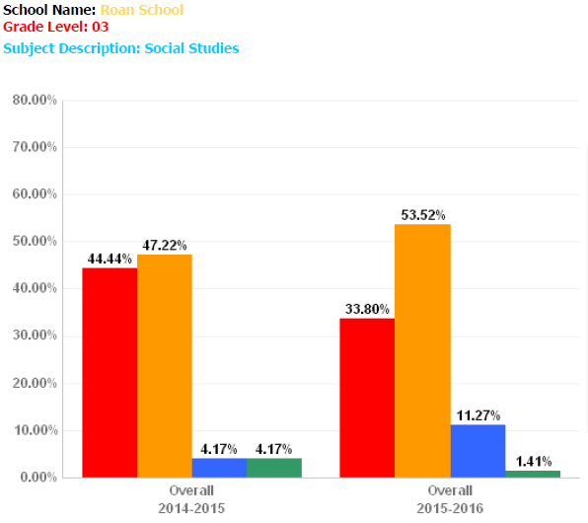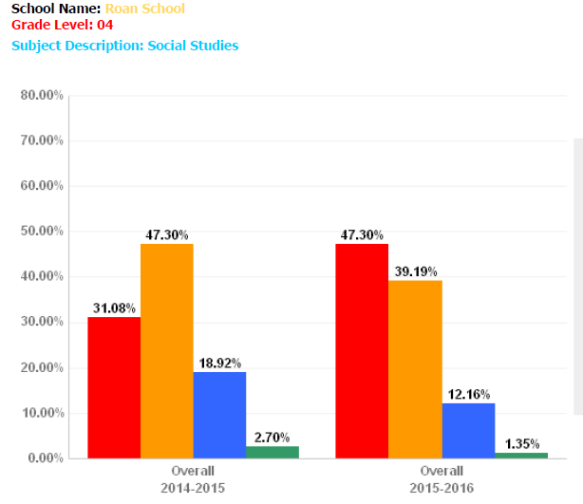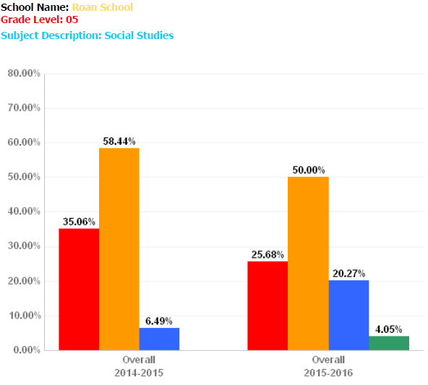
The data shows that Roan School saw a greater increase overall than the district increased. We increased in 6 of the 8 subgroups. The data also shows that our males increased while our females decreased. Our Blacks subgroup also decreased. The largest discrepancy among our subgroups is between our Blacks and our Hispanics.

 | 5th grade Writing |  | % Meeting/Exceeding Standard
 | System All Students | Roan All Students | Black | White | Hispanic | Asian | American Indian | Multi-racial | SWD | LEP
2011-2012 | 82 | 75 | Only 3 students | Only 3 students | 52 | Only 1 student | n/a | Only 1  student | Only 6  students | Only 6  students
2012-2013 | 75 | 66 | Only 4  students | Only 3 students | 68 | n/a | n/a | Only 4 students | Only 9  students | Only 6  students
2013-2014 | 80 | 79 | Only 4 students | Only 5 students | 80 | n/a | n/a | Only 1 student | Only 7  students | 40

5th grade writing | 2009-2010 | 2010-2011 | 2011-2012 | 2012-2013 | 2013-2014
Exceeds and meets | 60.4 | 54.8 | 75.0 | 66.0 | 79.0
Does not meet | 39.6 | 37.1 | 25.0 | 34.0 | 21.0

Roan School had a significant increase with overall students and the Hispanic population. We had only 3 students who exceeded on the 5th grade writing test for the 2013-2014 year. This is an area that we would like to improve on. Conventions was the area of most need.

Georgia Milestones 3rd grade Writing – Idea Development, Organization, and Coherence-
% of Students with Score Points of 3 and 4
 | System | Roan
2014-2015 | 19% | 7%
2015-2016 | 7% | 11%

Georgia Milestones 3rd grade Writing – Language Usage and Conventions
% of Students with Score Points of 3
 | System | Roan
2014-2015 | 10% | 8%
2015-2016 | 7% | 8%

Georgia Milestones 3rd grade Writing – Narrative Writing
% of Students with Score Points of 3 and 4
 | System | Roan
2014-2015 | 10% | 4%
2015-2016 | 5% | 1%

Georgia Milestones 4th grade Writing – Idea Development, Organization, and Coherence-
% of Students with Score Points of 3 and 4
 | System | Roan
2014-2015 | 25% | 21%
2015-2016 | 7% | 0%

Georgia Milestones 4th grade Writing – Language Usage and Conventions
% of Students with Score Points of 3
 | System | Roan
2014-2015 | 10% | 8%
2015-2016 | 3% | 0%

Georgia Milestones 4th grade Writing – Narrative Writing
% of Students with Score Points of 3 and 4
 | System | Roan
2014-2015 | 22% | 24%
2015-2016 | 20% | 12%

Georgia Milestones 5th grade Writing – Idea Development, Organization, and Coherence-
% of Students with Score Points of 3 and 4
 | System | Roan
2014-2015 | 36% | 5%
2015-2016 | 31% | 25%

Georgia Milestones 5th grade Writing – Language Usage and Conventions
% of Students with Score Points of 3
 | System | Roan
2014-2015 | 17% | 5%
2015-2016 | 29% | 23%

Georgia Milestones 5th grade Writing – Narrative Writing
% of Students with Score Points of 3 and 4
 | System | Roan
2014-2015 | 14% | 1%
2015-2016 | 28% | 48%

The data shows a substantial increase in Fifth grade writing for all domains. Specifically, Roan Fifth graders outperformed the system by twenty percent in narrative writing. Another area of growth included Third grade idea development, organization, and coherence. Fourth grade data shows a decrease in all domains. Percentages decreased meriting further investigation.
NRT – third grade | ITBS, Fall, 2009 NCE | ITBS, Fall, 2010 NCE | ITBS, Fall, 2011 NCE | ITBS, Fall, 2012 NCE | ITBS, Fall, 2013 NCE
Reading | 38 | 32 | 36 | 36 | 35
Language | 45 | 36 | 47 | 38 | 42
Math | 49 | 39 | 45 | 42 | 43

GKIDS
 | 2013-2014 | 2014-2015 |  | 2015-2016
English/Language Arts | % Meets/Exceeds | %Meets/Exceeds |  | %Meets/Exceeds
Reading | 87 | 80.8 |  | 88.8
Writing | 86.5 | 81.8 |  | 85.7
Listening/Speaking | 88.6 | 85.2 |  | 88.9
Language | 82.7 | 75.6 |  | 85.8
ELA Total | 85.8 | 79.8 |  | 87.5

Overall, the percentage is up in all areas from last year. Listening and Speaking is the highest score for GKIDS data at Roan. Even though gains were made in all areas, the Writing and Language scores were the lowest and may be a focus for this year.

GKIDS
 | 2013-2014 | 2014-2015 |  | 2015-2016
Mathematics | % Meets/Exceeds | % Meets/Exceeds |  | %Meets/Exceeds
Counting and Cardinality | 86.4 | 84.4 |  | 95.7
Operations and Algebraic Thinking | 79.8 | 82.8 |  | 76.3
Numbers and Operations in Base 10 | 80.0 | 78.2 |  | 71.4
Measurement and Data | 91.4 | 92.9 |  | 92.6
Geometry | 79.3 | 82.3 |  | 90.6
Math Total | 83.7 | 84.3 |  | 89.7

Counting and Cardinality is the highest score for GKIDS math. Numbers and Operations in Base 10 are the lowest score. This area continues to decrease. There is a gap between Math and ELA.

- We have based our plan on information about all students in the school and identified those groups of students who are not yet achieving the State Academic Content standards and the State Student Academic Achievement Standards including:

- Economically disadvantaged students
- Students from major racial and ethnic groups
- Students with disabilities
- Students with limited English proficiency

- Based on the data from the last five years, we reached the following conclusions regarding achievement. The major strengths we found at Roan School were:

- Data Specific Strengths:

  - Teachers have learned to analyze literacy data through the Literacy Collaborative Frameworks which has empowered them to make instructional decisions that will positively impact students.
  - Trained Reading Recovery and I3 teachers demonstrate lessons and lead mini workshops for teachers. As well as collaborate with classroom teachers on a regular basis, Reading Recovery and I3 teachers are also utilized when teaching small groups within the classroom through ELL/EIP/ESS.
  - Collaboration – 50 minutes twice a week committed to design work for students
  - One to One devices for 3rd, 4th, and 5th grade students/ K-2nd I-pad cart per grade level
  - Math Coach (District Math Initiative) and School based Math Teacher Leader
  - Access to iLab. This lab provides opportunities to explore (Science, Technology, Engineering, Math and Creativity).
  - Students continue to build their reading and writing processes and understanding the importance of literacy skills as a life-long learner.
  - Roan has partnered with the Schlechty Center for eight years to bring in consultant Sandy Jenkins to work with grade levels using the Coaching for Design model which equips teachers to design units for hard to teach content. The work with Sandy Jenkins helps teachers dig deep into the style of learning and engagement of students in their classrooms. Student voice and student interests aid in driving/increasing engagement levels. In order to assess the work designed for students, teachers also have a “redesign” session after each unit using student input and data.
  - 5th grade students will have the opportunity to work with DHS science teachers and students during an assigned field trip.
  - We believe by focusing on the designing of work for students rather than simply planning the work has been a critical component of engaging more students in the work they do. Therefore, as we have witnessed this level of engagement rise, we have also seen the scores of students increase in various areas.
  - Building and increasing our parent and community relationships
  - Partnership with Rock Bridge Community Church
  - Allocation of resources where they will result in the greatest impact for student learning
  - Continue student clubs: Chorus, Chess, Zumba, Lego, Coding, Art, Karate, Running, Track, Cheer, Morning Show, and Soccer

- Data specific weakness: The major needs we discovered were

- Math needs continued attention through increased instructional time, coaching, and professional learning.
- Integration of literacy across all subjects
- Errors in conventions for writing need to be reduced
- Speaking and Writing skills for ELL students
- Technology-professional development for teachers, need for devices in primary grades, integrated in instruction, basic computer skills for students

The needs we will address are:

- Math
- Fact Fluency schoolwide
- Professional development (Number Talks, Progressions in Math, etc)
- Flexible mathematical thinking
- Number Sense
- Extended Day Instruction (formerly Bobcat Academy)

- Speaking & Writing
Speaking:
  - Pre K-K: To be able to explain different situations in full sentences with reasoning and opinion
  - 1-2: To be able to give oral presentations on content based topics speaking in complete sentences
  - 3-5: To be able to give content based oral reports using academic vocabulary while speaking in complete sentences
  - Students will strive to become leaders in their communities.

Writing:
  - Pre K-K: To be able to create content based work independently using short sentences
  - 1-2: To be able to write with given scenarios extending the stories
  - 3-5: To be able to write summaries and produce extended responses using academic vocabulary citing evidence in both
  - Professional Development focused on ELL strategies (speaking) Text book study
- App purchases
- Guided reading text for Lit Study
- Audio devices
- Resources for story starters, writing prompts, and/or with word banks

- Conventions
  - IXL Language Arts purchase
  - Participate in professional learning in the area of conventions.
  - Schedule students to participate in state funded early intervention services.
  - Provide the opportunity for students to participate in an after school experience (Bobcat Academy)
- Reading
  - Add additional EIP support in 2nd – 5th grade
  - Benchmark Intermediate students in January
  - Benchmark Primary students in February
  - Teachers set goals for groups and individual students
  - Teachers trained in analyzing running records and using this information to guide their instruction

- Technology
  - Build in time for working on technology design
  - Professional learning
  - New DRT (Design Resources Team)
  - Each staff member assigned a member of DRT for technology support
  - 2 Technology Focus Days for staff with Schlechty consultant, Sandy Jenkins
  - New role for media specialist (Instructional Technologist)
  - 1:1 Devices for 3rd-5th grades
  - iPads for K-2
  - Canvas Instruction and use
  - Digital Citizenship
  - Coding

- The specific academic needs of those students that are to be addressed in the schoolwide program plan will be:

By 2017, data will be available to establish projections for growth in the Georgia Milestones Assessment. In 2016-2017, we will increase the number of students who move one or more proficiency levels within a year on the ACCESS test.

- The Root Causes that we discovered for each of the needs are:

- Math
  - Teachers need additional coaching on instructional strategies to teach all mathematics standards.

- Reading
  - Low reading scores on GA Milestones
    - % of students who are reading below grade level
    - % of students who need RTI reading
  - New to country students
    - Students enter without PK experience

- Speaking/Writing
  - Current mode of ELL instruction did not maximize academic content specific language opportunities.
  - The number of lessons designed to enhance speaking and writing skills needs to increased.

- Technology
  - Ongoing training needed for professional development
  - Lacked the capacity to support the number of devices for internet connection.

- Conventions
  - Teachers have not received coaching support and training which focuses on integrating Literacy Collaborative with explicit ELL instructional strategies in the area of conventions.

G) The measureable goals we have established to address the needs are:
- Math
  - Data will be used to establish projections for future growth in the area of math.
- Reading
  - 90% of students will move 4 guided reading levels in a year

- Speaking/Writing
  - Increase the number of students who move one or more proficiency levels on the Access Test within a year.

- Conventions
  - Data will be used to establish projections for future growth in the area of conventions in writing.

- English Learners
  - Students will increase one or more proficiency levels within a year based on the Access test
- Students with Disabilities
  - Data will be used to establish projections for student growth
- Economically Disadvantaged
  - Data will be used to establish projections for student growth
- Technology
  - Students will increase their knowledge for usage in technology.

- GKIDS
  - Kindergarten students will increase the % of meets and exceeds for ELA in the areas of Writing and Language
  - Kindergarten students will increase the % of meets and exceeds for Math in the areas of Operations and Algebraic Thinking and Numbers and Operations in Base 10

- Race/Ethnicity
  - Baseline data will be used to establish projections for subgroups

- By 2017, school will have a 3% ( in the gap distance) in its CCRPI score.

- School wide Reform Strategies

- Schoolwide reform strategies which provide opportunities for all children in the school to meet or exceed Georgia’s Proficient and Advanced Levels of Student Performance

The ways in which we will address the needs of all children in the school particularly the needs of students furthest away from demonstrating proficiency related to the State’s Academic Content and Student Academic Achievement standard are:

- Personnel
  - Reading Recovery Teachers
  - Literacy Collaborative Coaches
  - Bobcat Academy Teachers- Hiring after school tutors with title 1 funds
- Math
  - Purchase resources to promote math fluency.
    - Explore and purchase the best available math resources available to be used with students.
  - Purchase equipment and materials for an iLab to promote math and science.
    - To build families capacity to support students in these academic areas.
  - Professional learning
    - To increase the capacity of teachers in all math standards
- Reading
  - Target specific reading levels and purchase quality texts at that level
  - Provide online student support for constructed response
  - Professional learning to support teachers and coaches
  - Digital Online Leveled Texts
  - Supplies to support reading and writing for Literacy Collaborative Framework

- Speaking and Writing
  - App purchases
  - Purchased Guided Reading texts for Lit study
  - Leader opportunities for students

- Conventions
  - Purchase Conventions Read-Alouds
    - Access to convention read alouds will increase student knowledge and comprehension about conventions.
  - IXL Language Arts
    - To increase the opportunity for students to practice convention skills at multiple levels regardless of their grade level.
  - Professional learning
    - To increase the knowledge of staff members in the area of conventions through training with Literacy coaches.

- Technology
  - Instructional Framework
  - Design Resource Team (DRT)
  - iLab – furniture/equipment/materials
  - Digital Citizenship
    - To learn about safe online practices.
  - Professional Development-build capacity for teachers in the area of technology
    - Sandy Jenkins/Consultant

- Following are examples of the scientifically-based research supporting our effective methods and instructional practices or strategies:

Math was identified as content area weaknesses at Roan. Sherry Parrish (2010), in her book Number Talks, says, “number talks is a pivotal vehicle for developing efficient, flexible and accurate computation strategies that build upon the key foundational ideas of mathematics such as composition and decomposition of numbers, our system of tens, and the applications of properties. Classroom conversations and discussions around purposefully crafted computation problems are at the very core of number talks. These are opportunities for the class to come together to share their mathematical thinking.” Ruth Parker says, “The practice of number talks is one of the most powerful vehicles known for helping students learn to reason with numbers an make mathematically convincing arguments, for building a solid foundation for algebraic reasoning, and for teaching mathematics as a sense making process.” Teachers at Roan are implementing Number Talks into the day and are beginning to make this shift in their practice.
In addition, teachers at Roan are using the below benchmarks to differentiate their math instruction. Initially, teachers need to identify the knowledge and strategy stages of all students. This information can then be used to group students for instruction and provide direction for teaching and learning. Assessment tools useful for this purpose include:
- Global Strategy Stage assessment (GloSS) used to assess students’ strategy stages
- Individual Knowledge Assessment for Numeracy (IKAN) used to assess students’ knowledge stages
These tools are also used to determine student progress over time, and provide valuable information for reporting purposes. https://nzmaths.co.nz/
- GloSS
The GloSS assessment enables you to identify the strategy stage students are operating at across all three strategy domains, known as the global strategy stage. It consists of a series of strategy questions that can be administered to individual students in a few minutes. Multiple forms of the interview are available so that students do not become too familiar with the questions.

- IKAN
The IKAN assessment identifies the knowledge stages students are operating at across all five knowledge domains, known as the global knowledge stage. The IKAN interview is for students at the counting stages of the number framework. It can be carried out formally in a one-on-one situation or in a small group setting. The IKAN written test is for students at the part-whole stages of the number framework. Whilst IKAN informs what we know about a student's number knowledge, this assessment on its own is insufficient to give a full picture of a student's achievement in number.
Parrish, S. (2010). Number Talks. Sausalito, California: Math Solutions
Retrieved from: https://nzmaths.co.nz/
We will continue our extended day program “Bobcat Academy” for students who need extra help. This program is designed to assist students in grade 3-5 in the areas of math and reading. We will utilize technology applications to support instruction and enhance learning for students. The Bobcat Academy will begin in January and services will be provided until the Georgia Milestones. The students will meet twice a week from 4:00 – 5:30. In addition, we also hire an academic coach to work with boost groups for 4 hours a day. The teacher will serve 3rd – 5th graders during the day and provide additional support for students who are below grade level in reading and math.
Reading- Research shows that the Literacy Collaborative make a sustainable difference for students. Literacy Collaborative, Reading Recovery, and Leveled Literacy Intervention have been tested by rigorous studies that:
- Address the needs of different types of readers—struggling, average, achieving and high achieving
- Use a variety of methodologies and data types
- Consider quality of implementation
- Examine short and long term effects on literacy achievement
- Consider outcomes for students, teacher, and schools
- Range in scope from deep explorations of single schools to large national trials
Literacy Collaborative is a nationally-recognized, comprehensive school literacy improvement model designed to help teachers ensure that all students become successful readers and writers. Every year, Literacy Collaborative schools collect and analyze data on student growth and achievement to evaluate their effectiveness, inform decisions about students, and improve their implementation of the model.
Established in 1993, LC is a comprehensive school reform program designed to improve elementary children’s reading, writing, and language skills primarily through school-based coaching. LC is committed to the idea that teachers need both training in particular procedures and opportunities to analyze their teaching with a “more expert other”. Grounded in Bruner’s theory of instruction as scaffolding a (Bruner, 1986, 1996) and Vygotsky, 1978), such PD aims to support over time the development of the deep understandings that teachers need to continuously improve their practice. LC coaching is centered on a comprehensive approach to literacy instruction that focuses on engaging students at all ability levels in the reading and writing processes.
Roan School is in its’ 14th year of Literacy Collaborative implementation. As a school, we need to continually assess what teachers, coaches and administrators bring to the table and how that impacts our LC implementation, and how the social organization of the school influences innovation take-up and diffusion.
(www.lesley.edu/center-for-reading-recovery/research-and-outcomes)
Biancarosa, G., Bryk, A., & Dexter, E. (2010). Assessing the Value-Added Effects of Literacy Collaborative Professional Development on Student Learning. The Elementary School Journal, 111(1), 7-34. doi:1. Retrieved from http://www.jstor.org/stable/10.1086/653468 doi:1
Conventions – Kathleen Cali (2002), of LEARN NC, stated “Mechanics are the conventions of print that do not exist in oral language, including spelling, punctuation, capitalization, and paragraphs. Because they do not exist in oral language, students have to consciously learn how mechanics function in written language.” The National Council of Teachers of English, A Professional Association of Educators in English Studies, Literacy and Language Arts, commissioned a Writing Study Group in 2004 to study how the nature of writing has changed. "Just as the nature of and expectation for literacy has changed in the past century and a half, so has the nature of writing. Much of that change has been due to technological developments, from pen and paper, to typewriter, to word processor, to networked computer, to design software capable of composing words, images, and sounds. These developments not only expanded the types of texts that writers produce, they also expanded immediate access to a wider variety of readers."(2004). Educators agree that readers expect writing to conform to their expectations, to match the conventions generally established for public texts. Additionally, the study group concluded that "Contemporary readers expect words to be spelled in a standardized way, for punctuation to be used in predictable ways, for usage and syntax to match that used in texts they already acknowledge as successful. They expect the style in a piece of writing to be appropriate to its genre and social situation." Every teacher has to resolve a tension between writing as generating and shaping ideas and writing as demonstrating expected surface conventions. When writing teachers put too much emphasis on correctness they may unintentionally inhibit a writer's ability to develop a piece of writing. By the same token, without mastering conventions for writing, writers' efforts may not be recognized. Therefore, to strengthen the core academic program, each teacher must be knowledgeable enough about the entire landscape of writing instruction to guide students toward a goal, developing pieces of writing in a variety of genres as well as mastery of conventions. We need our Literacy Coaches and Reading Recovery teachers to continue to strengthen the instruction in Reading, English Language Arts and Writing.

Cali, K. (2002). The Five Features of Effective Writing. Retrieved from LEARN NC: http://www.learnnc.org/lp/editions/few/679
Speaking and Writing- In order for students to be successful, The British Council (2014) stated, “ELL learners need support to structure their speaking and writing, to use new language forms and functions appropriately and consistently, and eventually to speak and write independently using appropriate genres.” Educators agree that formal and informal language is necessary in order for students to become college and career ready. According to the National Governors Association Center for Best Practices and Council of Chief State School Officers (2010), “Students must have ample opportunities to take part in a variety of rich, structured conversations—as part of a whole class, in small groups, and with a partner—built around important content in various domains. They must be able to contribute appropriately to these conversations, to make comparisons and contrasts, and to analyze and synthesize a multitude of ideas in accordance with the standards of evidence appropriate to a particular discipline. Whatever their intended major or profession, high school graduates will depend heavily on their ability to listen attentively to others so that they are able to build on others’ meritorious ideas while expressing their own clearly and persuasively.” Educators are able to prepare students for the future by incorporating daily lessons on speaking and writing into the classroom.

Corwin. (n.d.). The Common Core State Standards. Retrieved from Corwin.com: http://www.corwin.com/upm-data/57185_listening.pdf
Council, B. (2014). Great Idea: Speaking and Writing Frames. Retrieved from British Council EAL NEXUS: https://eal.britishcouncil.org/teachers/great-ideas-speaking-and-writing-frames

Technology was identified as a content area weakness at Roan School. Through research conducted Boethel & Dimock (1999) describe that when teachers blend technology into constructivist learning situations, student achievement is positively impacted (Hernandez-Ramos, 2005). "A teacher's proficiency with computers will affect his or her willingness to integrate technology into the curriculum" (Hernandez-Ramos, 2005, p.47). To strengthen the instructional practices of teachers and academic achievement of students, teachers at Roan will have the opportunity to seek expertise through professional learning. "Effective integration of technology is achieved when students are able to select technology tools to help them obtain information in a timely manner, analyze and synthesize the information, and present it professionally. The technology should become an integral part of how the classroom functions -- as accessible as all other classroom tools" (National Educational Technology Standards for Students, International Society for Technology in Education).

Hernandez-Ramos, P. (2005). If Not Here, Where? Understanding Teachers' Use Of
Technology In Silicon Valley Schools. Journal of Research on Technology in
Education, (38)1, 47.
Boethel, M., & Dimock, K. (1999). Constructing with technology: A review of the literature. Southwest Educational Development Laboratory. Austin, TX.
International Society for Technology in Education.(2002). National educational technology standards for students. Retrieved July 2015, from http://cnets.iste.org/students/index.shtml

c) We will increase the amount and quality of learning time by offering Bobcat Academy. This is an extended day for students in grade 3-5 that begins in January and ends before the state standardized test in April. We will increase the quality of learning by more deliberately and purposefully integrating STEM in our new iLab and math content. We will increase the amount and quality of learning by attending professional development created by the literacy coaches. Reading Recovery teachers will work with students
d) The needs of all children, particularly targeted populations, will be considered with math and science, writing instruction that provides for individualized and differentiated experiences. Standardized reading and math scores will identify low performing students who may be eligible for additional services through EIP, ESS, I3 and Reading Recovery programs.
An annual review of data will determine if such needs have been met and will be consistent with improvement plans approved under the Elementary and secondary Education Act of 1965 (ESEA)
e) Additional strategies to address the needs are:
Counseling
Pupil services
Mentoring services
College and Career Awareness and preparation
Innovative teaching methods
Co-teaching model for ESS
f) Dalton Public Schools does not allow title 1 monies to be used for field trips

- Instruction by Highly Qualified Staff
We will provide instruction by highly qualified teachers who meet the standards established by the state of Georgia. Roan’s staff is an inspired group of professionals who are devoted to the core business of ensuring that all students are provided with engaging, quality work that results in the students learning what they need to know. From maintenance/housekeeping to the principal, all are motivated to meet the instructional needs of students. All of the Roan staff is highly qualified for the 2016-2017 school year. We have 8 teachers with a Bachelor’s degree, 18 teachers with a Master’s degree, 17 teachers with an EdS (Specialist) degree and 2 teachers who have their doctorate. In addition, 14 certified teachers have over 20 years’ experience, 14 certified teachers have between 11-19 years’ experience, 10 certified teachers have between 5-10 years’ experience and 7 teachers between 1-4 years’ experience. Dalton Public Schools makes every effort to attract highly qualified and quality teachers who share the vision and beliefs of the school system. Human resources personnel and certified staff members seek quality applicants through job fairs hosted by colleges and universities around the Southeast. Prospective graduates from area degree programs are afforded the opportunity to observe, intern, and student teach within the school system, providing another avenue for targeting quality applicants.
The DPS website provides prospective applicants with exciting details about the
system in general while the school site provides school specific information. DPS will
continue to offer an intense but informative new teacher induction, and Roan will further induct new staff on site. Staff induction is continued in the following ways: admin meets with new hires before the start of the year to discuss handbooks and procedures, a buddy or mentor is assigned, and each staff member meets with administration for a “Get to Know You” meeting. Also, ongoing conversations are held with new staff throughout the first three years to provide assistance where needed. The district continues to attract teachers from surrounding cities and states by offering on-going professional learning opportunities, clean and attractive buildings, competitive salaries and benefits, high academic standards for all students, and an opportunity to work in a culturally diverse community.

4) Professional Development

a) We have included teachers, principals, and paraprofessionals and, if appropriate, pupil services personnel, parents, and other staff in our staff development that addresses the root causes of our identified needs. For example, Roan has an extensive professional development program in addition to that which is provided as a part of the school system’s affiliation with the Schlechty Center and Literacy Collaborative. The focus is on continuous school renewal and improvement and on professional learning that is tied to the school’s vision and beliefs. Over the past five years, staff members have attended a number of professional learning opportunities including:

3D – Dalton Public Schools Professional Learning
Onsite Literacy Collaborative training
Intermediate Ongoing Literacy Collaborative Coaching training in Cambridge, MA
Academy for Innovative Leaders, Naples, FL
Health MPowers on site training
SIOP training provided at the district level
GaETC conference in Atlanta GA
Brenda Erwin Math Professional Learning
Reading Recovery continuing contact class each month
GKIDS training
PK Professional training
Writing training from Literacy Coaches
Schlechty Center’s Working on the Work Conference –Atlanta, GA, Chattanooga, TN and Dalton, GA
Schlechty Center’s Coaching 4 Design in Louisville, KY
On site training with Sandy Jenkins from Schlechty Center for the past 8 years
Authentic Assessments – Everette Kline
Effective Literacy Leaders Conference – Cambridge, Mass., Irene Fountas
Southeastern Reading Recovery and Early Literature Conference
Recruitment and Induction - Schlechty Center
Georgia Technology Conference
Children’s Literature Conference - Athens, GA
National Children’s Literature Conference – Washington, DC
Parent opportunities offered through Sharing is Caring workshops and PAWS 2.0
Great Parents Academy
Participation of the staff working on higher level degrees
Attendance and participation of our Roan School council
Innovators Inc./PAWS 2.0
District Design Team
Family Engagement Conference 2014 2016
Leader in Me conference 2015

b) We have aligned professional development with the State’s academic content and student academic achievement standards in the areas of science, writing and math.
All of our school’s Title 1 funded professional development have been aligned with our needs assessment. Each professional development activity has been reviewed to ensure the training is related to Georgia’s academic content with the goal of raising student achievement in content areas identified within our needs assessment.

- We have devoted sufficient resources to carry out effectively the professional development activities that address the root causes of academic problems. For example,
- Administrators will meet with LC coaches monthly to discuss student achievement and to analyze student data.
- Our Math team, Literacy team and Roan School Design Teams meets monthly to discuss and create professional learning experiences.
- Money- Consultants
- Time
- Resources
- Academic Coaches/intervention specialist
- Technology
- Purchase of necessary materials for training

d) We have included teachers in professional development activities regarding the use of academic assessments to enable them to provide information on, and to improve, the achievement of individual students and the overall instructional program in the overall instructional program in the following ways…
- The Literacy Collaborative framework has provided teachers with extensive opportunities to learn how to gather assessment data and analyze it in a timely manner to determine the best instructional decisions for all students.
- Teachers were trained during the 2013-2014 school year in using the state’s longitudinal data system (SLDS) for gathering student performance data and instructional resources efficiently.
- Staff meetings opportunities for
  - Data analysis
  - Reading and understanding assessment reports
  - Discussion of student data with parents
  - Development of common assessments

Paraprofessionals have received training from the primary literacy coach in ways to support LC in the classroom. Paras also attend other professional learning opportunities that are offered at the school and may sign-up and attend system trainings offered by the technology department or the local RESA.

5). Strategies to attract high quality teachers to high need schools

We will provide instruction by highly qualified teachers who meet the standards established by the state of Georgia. Listed below are ways that Roan School does try to attract highly qualified teacher by;
  - Partnering with colleges/universities to provide field experiences or internships
(Lee University, Cleveland State, Kennesaw State University and Dalton College)
  - Providing school mentors for new hires
  - Scheduling one hour “Get to Know You” meetings with new hires and administration
  - Providing on site opportunities to earn PLUs
  - We take recommendations from district office regarding recruitment of new teachers from colleges and universities.

6) Strategies to Increase Parent Involvement

a) We will involve parents in an organized, ongoing, and timely way in the planning, review and improvement of schoolwide programs and the school parental involvement policy by continually asking for written and verbal feedback through formal and informal conversations, and active participation in school projects and events. Invitations are sent home with all students, posted on web site and in office and on doors to front of school.

b) We will update the school parental involvement policy periodically to meet the changing needs of parents and the school and distribute it to the parents of participating children and make the parental involvement plan available to the local community, by:
  - posting on the school website
  - providing hard copies available in the school office
  - making available at Picnic in the Park, PTOs, and other meetings
  - making available to new parents as they enroll

We have developed a parent involvement policy included in our appendix that

- includes strategies to increase parental involvement
- describes how the school will provide individual student academic assessment results, including an interpretation of those results
- makes the comprehensive schoolwide program plan available to the LEA, parents, and the public (internet, and/or newsletters)
- requires signed compacts
- includes a parent involvement checklist

- We will conduct an annual meeting, at a convenient time, to inform parents about the school’s Title 1 program, the nature of the Title 1 program, the parents’ requirements and the school parental involvement policy, the schoolwide plan, and the school-parent compact and encourage and invite all parents of participating children to attend on Tuesday, September 27, 2016. Parents will receive an invitation by their child and it will be posted on the web site as well as posted in the office. Schoolwide written communications sent home to parents in English and Spanish.

- We will offer a flexible number of meetings for the Title 1 Annual Parent meeting, such as meetings in the morning or evening, and may provide, with funds provided under Title 1, transportation, child care, or home visits, as such services relate to parental involvement by:
  - On September 27, 2016 we will conduct our Title 1 Parent annual meeting at 4:00 pm in Room 256.

- We will provide parents of participating children with timely information about the Title 1 program, a description and explanation of the curriculum in use at the school, the forms of academic assessments used to measure student progress, and the proficiency levels students are expected to meet, and provide opportunities for regular meetings, if requested by parents, to formulate suggestions and to participate, as appropriate, in decisions relating to the education of their child, and respond to any such suggestions as soon as practicably possible, by providing information at our annual parent meeting via a PowerPoint and discussion.

- We will jointly develop with parents of participating children a school-parent compact that outlines how parents, the entire school staff, and students will share the responsibility for improved student academic achievement and the means by which the school and parents will build and develop a partnership to help children achieve the state’s high standards by providing an opportunity for parents to give input into the draft compact if they do not attend meetings. The finalized compacts are distributed and shared with parents. The compact describes the roles and responsibilities of parents, students, teachers and principal to ensure student success.

- We will provide assistance to parents of participating children, as appropriate, in understanding the state’s academic content standards, the state’s student academic achievement standards, the state and local academic assessments including alternate assessments, the requirements of Title 1, Part A, how to monitor their child’s progress and how to work with educators by providing translators at parent conference, annual parent meeting, PTO meetings and RTI meetings.

- We will provide materials and training to help parents to work with their child to improve their child’s achievement, such as literacy training and using technology, as appropriate, to foster parental involvement, by inviting parents to our family nights. We will offer a Literacy family night this school year. In addition to opportunities to be involved in activities at the school, Roan works with parents to help their children academically through the use of web-based software. Additionally, parents can directly assist their child with self-paced assessments and games from home. Some of the available resources include the following:
- Infinite Campus: online access to student grades, assignments, and attendance
- IXL – online dynamic math practice
- Reflex
- Bookflix: online digital storybooks for students
- Home visits
- Walk to School program
- Parent Engagement Conference
- Book Study of Whole New Mind
- Parent University
- Computer Classes for Parents
- Workshops
- Guidance Counselor Dr. Mary Ann Hensley

- We will provide training to educate the teachers, pupil services personnel, principal, and other staff in how to reach out to, communicate with, and work with parents as equal partners, in the value and utility of contributions of parents, and in how to implement and coordinate parent programs, and build ties between parents and the school, by recognizing the critical role of a strong parent involvement program. New teachers will attend a session on parent conferencing. The session will have videos to watch, discussion on best practices, and guidance on a variety of strategies.

- We will, to the extent feasible and appropriate, coordinate and integrate parental involvement programs and activities with Head Start, Even Start, Home Instruction Programs for Preschool Youngsters, the Parents as Teachers Program, and public preschool and other programs, and conduct other activities such as parent resource centers, that encourage and support parents in more fully participating in the education of their children by providing workshops from our counselor, the DPS title 1 parent coordinator and PK parent coordinator. The Pre-K peek is offered in the spring for upcoming students to visit our school and to meet the teachers.

- We will take the following actions to ensure that information related to the school and parent programs, meetings, and other activities, is sent to the parents of participating children in an understandable and uniform format, including alternative formats upon request, and, to the extent practicable, in a language parents understand by providing all communication in English and Spanish. Translators are provided when needed at all meetings.

- We will provide full opportunities, to the extent practicable, for the participation of parents with limited English proficiency, parents with disabilities, and parents of migratory children, including providing information and school reports required under section 1111 of the ESEA in an understandable and uniform format and including alternative formats upon request, and, to the extent practicable in a language parents understand by providing written and or verbal communication in English and Spanish. Ex) ELL meetings, IEP meetings, RTI meetings, and parent conferences

The culture of Latinos leans to family oriented and family centered activities coupled with a high respect for school and education. Capitalizing on this knowledge, the school provides meaningful opportunities for the entire family to participate in school activities. When students, parents, teachers or community members are asked what they remember most about Roan School, they often reply, “Family Night.” Since 1995, Roan School has been hosting family nights. These occasions are planned by the Parent Involvement Team but all staff members participate and help make them a success. For the past twenty one years, Roan School has been able to attract an overwhelming amount of participation from the families of Roan School because of the well planned and executed events that have been offered. The heart of Roan School staff has been the driving force that has kept these festivities alive. The Picnic in the Park, Fall Carnival, Holiday Content Night, Art Night, Science Night, Literacy Night, Reading Night, and Music Night are some of the themes for past Roan family nights. The average attendance is 500 guests with an all-time high of 1,100 guests. The time frame for family night events, 5:00 to 6:30 p.m., has been vital due to the fact that many of Roan’s parents work in carpet mills. Roan parents who leave work at 3:00 p.m. are able to participate and parents who begin work at 7:00 p.m. are able to come for most of the time. Another key factor has been the selection of activities in which all family members, regardless of age, can participate. These nights are packed full of fun for everyone. Door prizes, live entertainment, and special guests often highlight these events. Roan family nights are a tradition and will continue to draw large crowds because of the vision and hard work of the Roan staff. In the 2016-2017 school year, we will host a Literacy night in September 2016 and a Holiday Content night in December 2016. We use all of our parent involvement money to support our Family nights.
To increase parent involvement, three teachers originated (PAWS- Parents Always Willing to Support) to gain parent voice. The recommendations from the parental group are used to design new experiences for Roan School. Thirty parents were in attendance for the November 2011 meeting to help redesign our December Family Night. At the end of the 2011-2012 school year, we had a year-end social with approximately 200 family members in attendance. The three teachers wanted our PAWS program to become more innovative. They were accepted into Innovators Inc. during 2013 to redesign our PAWS program. We will begin full implementation of the new PAWS 2.0 in January 2017.
Parent involvement is recognized as vital to the academic development of children. Roan’s School Council was implemented in 2001-2002 and quickly became an important part of the decision making process through its recommendations. Four parents, two teachers and the principal serve on this seven member council. All staff members contribute to the communication of academic goals to parents throughout the year.
In the fall from 2003-2016, we have had 100% of Roan’s parent/primary caregivers attended the fall parent conference. Parents, staff, and students also sign a compact. The contract is a written agreement between Roan staff, students, and parents identifying shared responsibilities for student achievement and success. Though language presents a barrier with home/school communication, ongoing efforts are made to overcome this challenge. Written communication is sent home in both English and Spanish. Bilingual translators are assigned to help teachers during parent teacher conferences. When parents enter Roan School, they are greeted by bilingual personnel. We have 16 bilingual staff members at Roan School.,

7) Preschool and Elementary Transition

We will plan activities for assisting preschool children in the transition from early childhood programs. Following are our plans for assisting preschool children in the transition from early childhood programs. Also included are transition plans for students entering middle school or high school and entering from private schools plus students entering our school throughout the school year.
Several system prekindergarten (PK) classes feed into the kindergarten program at Roan. A primary focus in the PK program is to improve language, socialization, and literacy skills. Teachers work within the Bright from the Start framework for Georgia PK students as well as introducing kindergarten skills when appropriate. One system transition coach plans for the transitioning of students. This often includes a visit to the school for students and their families. Prospective students to our PK program take annual tours of the school each spring during the PK Peek. Students meet the principal and visit classrooms, the cafeteria, the media center, the gym and other places in the school.
Building administrators also visit area PK programs and meet prospective students. These students have an opportunity to meet the principal and have lunch or cookies together.
Each spring all of our fifth grade students take a field trip to Dalton Middle School for their transition experience. Students are able to participate in a scavenger hunt as they learn their way around the school building. They meet the DMS administration and teachers.
At the beginning of each year, we conduct an orientation session for parents and students to visit the school. During orientation they meet their new teachers, explore the classrooms, and complete necessary documentation. This year for open house/parent conferences, we offered grade level specific parent nights to deliver content specific information. We will have our 4th annual Roan School Picnic in the Park in the Spring.

8) Measures to Include Teachers in Decisions

The ways that we include teachers in decisions regarding use of academic assessment are through routine collaborative data analysis and gallery walks.
Eight years ago, Roan began to implement the Working on the Work framework. We have a Design Team that consists of 11 members which includes the principal, assistant principal, teachers and support staff. The major role of the team is to lead the school in designing engaging work for students and designing engaging experiences for teachers—all focused on school transformation. This team meets once a month. Also, The Design Team oversees the implementation of instructional frameworks, particularly Literacy Collaborative, and monitors the implementation to be sure all standards and guidelines are followed. Routine matters such as scheduling, facility use, and dissemination of information are handled through this team.
The Evidence and Assessment Team, which consist of 11 members, has the role of analyzing student data to identify trends and next steps for the purpose of improving student achievement.
Each grade level has a designated chairperson that serves as a liaison to the Roan Staff. Information is sent via email to the liaisons which in turn share and get feedback from other grade level members. We are able to get whole staff input through this procedures. Our collaboration schedule for this year, allows all grade levels to have 50 minutes of collaboration as well as monthly grade level meetings. Teachers in each grade level meet during this time to design quality and engaging work for students. Teachers use assessment data to determine the steps to take in order to help students meet state goals and objectives. Grade level collaboration time allows for information to be discussed and needed feedback made for staff input. Grade level information is reported back to administrators through collaboration notes. The Literacy Coach meets monthly with grade levels to analyze literacy data together to determine next steps for all students’ instruction.
Report cards and rubrics are discussed with parents during our fall conferences where we meet with 100% parents.

9) Effective and Timely Assistance

- We are providing activities to ensure that students who experience difficulty mastering proficient or advanced levels of academic achievement standards shall be provided with effective, timely, and additional assistance. Those activities are (especially for those students who are struggling) Early Intervention Program (EIP), English Language Learners (ELL), Reading Recovery (RR), Exceptional Student Services (ESS) and Leveled Literacy Intervention (LLI). Reading Recovery is implemented as a safety net for first grade learners. Two Reading Recovery teachers each work 1:1 with four students daily to provide a structured literacy intervention designed to assist students in attaining the average reading level of their peers. Additionally, the RR teachers teach Guided Reading groups during the EIP and ELL segments. Literacy Lessons, which offers 1:1 instruction for ESS students, is provided. Leveled Literacy Intervention (LLI) is implemented as an intervention to kindergarten through fifth grade students. Two Literacy Coaches are provided to assist and lead teachers in their growing their capacity of the LC framework. Ten full time English Language Learner (ELL) teachers and Early Intervention Program (EIP) teachers are available to identify and serve those students who qualify for support services targeting the improvement of instructional achievement for naïve learners. Exceptional Student Services as well as speech and language services are used to support students who qualify. The Challenge program enhances the learning of accelerated learners five days per week, onsite. Fifth grade challenge students have the opportunity to participate in specially designed projects and learning at the C3 enrichment center once a week. The Bridges program provides math instruction to students above grade level in 1st through 5th grades. Students are identified for specific needs through careful analysis of assessment data and the tiered Response to Intervention (RTI) program. RTI structures are in place to allow for customized learning experiences for children who need additional assistance. Tiered interventions are developed in cooperation with the school RTI team and classroom teachers.
Additionally, all students at Roan School have access to IXL.com. This web-based tool allows students to work at their own pace to complete grade-specific content assessments and games. If specific content is too difficult for students, remedial work is required before students are allowed to move forward in the lessons.
Roan recognizes and responds to the physical, social, and emotional needs of students. A full-time counselor regularly conducts guidance lessons for each class weekly, and is available for small group and individual counseling. A full-time nurse staffs the school clinic and responds to the physical/medical needs of students. A part time social and outreach worker are assigned to the school to assist families.
We will continue our extended day program “Bobcat Academy” for students who need extra help. This program is designed to assist students in grades 3-5 in the areas of math and reading. We will utilize technology applications to support instruction and enhance learning for students. Bobcat Academy will begin in January and services will be provided until the Georgia Milestones test. The students will meet twice a week from 4:00-5:30.

b) Teachers of the aforementioned special services are generally the same teachers who administer eligibility testing and confirm student placement into special services. These teachers are trained to use specific observation tools and standardized tests as recommended by their respective areas of service.
c) In the fall from 2003-2016, we have had 100% of Roan’s parent/primary caregivers attended the fall parent conference. When it is determined that students will benefit from additional assistance, parents are notified and the defined scope and sequence of the plan to provide assistance is discussed. Information is also shared with parents to explain how they can support and assist students in the home. Parents, staff, and students also sign a parent compact. The contract is a written agreement between Roan staff, students, and parents identifying shared responsibilities for student achievement and success.

d) Reading Recovery teachers also meet with parents of selected students and have a contract/agreement that parents sign for students to receive services.

10) Coordination and Integration of Federal, State and Local Services and Programs

Roan School utilizes a variety of programs available to create a high quality comprehensive educational program for its students. With a diverse population of students, a variety of specialized programs are needed to provide significant academic growth. The various programs are coordinated within the school day so that resources can be shared to benefit all students. The following programs and resources are utilized into the schoolwide program at Roan School:

- Title 1
- Early Intervention Program
- Exceptional Student Services
- English Language learners
- Bright from the Start PK
- Professors and student interns and teachers from Universities
- Dalton Police and Fire Departments
- Roan PTO
- Translators through Morris Innovative High School
- Boy Scouts
- Girl Scouts
- Junior Achievement
- Migrant Assistance
- School Social Worker
- Rock Bridge Partnership

Technology Equipment and Internet Services that are utilized include:

- Mounted Projectors and Screens
- Student Response Systems
- Digital Cameras
- FLIP video cameras
- Ipads
- Itouch
- Kindle Fire
- Wii Remotes
- Document Cameras
- Brain Pop
- IXL
- Headphones
- Smart boards
- Recordx
- Tumblebooks
- Pebblego
- Pebblegonext
- Reflex math

Title I Resources are budgeted for:

- Reading Recovery teachers
- Literacy Coordinators
- Extended Day (Bobcat Academy)
- Sandy Jenkins from Schlechty Center and other consultants
- Web-based supplemental instructional programs
- Supplies and materials for iLab
- Supplies and materials for Literacy
- Supplies and materials for Math
- Supplies and materials for Writing
- Professional Learning
- Parent involvement activities- Family Nights- ex Literacy

Title III Resources are budgeted for:
- Resources
- Coach digital

Developing the Title 1 plan at Roan School is an annual process. Local, state, and federal programs are coordinated and enhanced through the development and distribution of the plan. The plan is developed in coordination with staff, School council and parents. Additionally, the opportunity for community feedback regarding the plan is accessible through our school website. The Title 1 plan is shared with the LEA and is available throughout the year-long cycle from our website and our school office. Translation is provided as requested.

11) Interpretation to Parents/Reporting of Assessments/Provisions for Reporting Disaggregated Data

Formative and summative assessments are shared with parents through a variety of mediums. Periodically scheduled parent conferences and student progress reports are two primary avenues for sharing performance. An internet parent portal is also available so that teachers may communicate with parents. Also, written reports are sent home to parents of individual students detailing performance on various tests and how individual performance compares to other students in the same grade. The Georgia Milestones test results are provided to parents. ACCESS results are also reported to parents. Parent-teacher conferences are conducted formally and informally as needs arise. Other parent conferences, which are held to share information, could include Response to Intervention (RTI), English Language Learners (ELL), Exceptional Student Services (ESS), Gifted Services and Bridges Services. Other conferences may include meetings with a Social Worker and Counselor.
Authentic Assessments and standardized criterion-referenced test results are used to pinpoint areas of strengths and weakness. These scores are used to compare data from year to year and grade to grade. The third and fifth grade Georgia Writing Assessment results are used to determine progress toward school writing achievement goals. GKIDS is an assessment used to determine kindergarten readiness for first grade. School level scores and other results are disseminated through the news media, State School Report Cards, and parent meetings. State policy and local system reporting guidelines determine the type of information reported to the public.

12) Assessment Results/Collection and Disaggregated of Data

For state required assessments, data is collected and disaggregated by the state of Georgia
Roan School follows local mandates, state standards and federal guidelines regarding the assessment of students for the purpose of obtaining achievement data. This year we will use the Georgia Milestones for students in grades 3-5, Georgia Kindergarten Inventory of Developing Skills (GKIDS), Observation Survey (OS), and any other system mandated measures used to assess students. Additionally, a Literacy Evaluation Plan is written each year and data is collected as outlined in the plan.

Provisions are made for the collection and disaggregation of data on the achievement and assessment results of students. Kindergarten students will be assessed using the GKIDS. All students in grades 3-5 will take the Georgia Milestones in the spring. Teachers will access the results through individual student profiles. Disaggregated assessment data will be analyzed and used by teachers to plan appropriate instruction in areas of need. Assessment results are explained and discussed with parents during parent-teacher conferences.
At the end of each term K-5 students receive a standards-based report card. Standards-based reporting of student achievement leads to focused dialogue between parents and teachers regarding student progress which provides parents a clearer picture of student performance levels.
Categories for the disaggregated assessment results are based on data entered into Infinite Campus.
Staff members collect a variety of soft data for the purpose of planning for instruction and monitoring student achievement such as running records, high frequency word test, fact fluency tests, and anecdotal records. These ongoing evaluations of student performance are used to differentiate instruction to meet students’ individualized needs as they progress toward mastering goals and objectives.

13) Valid and Reliable Disaggregated Results

For state required assessments, the State of Georgia has assured the validity and reliability of the disaggregated assessments. Provisions are made to ensure that disaggregated assessment results for each category are valid and reliable. Assessments are those required by the state of Georgia and are judged valid and reliable by the Georgia Department of Education. Categories for the disaggregated assessment results are based on data entered into Infinite Campus. Accurate, up-to-date student data in Infinite Campus is the responsibility of the data clerk.
Through a variety of sources, data is analyzed to determine student achievement. Considering the ethnic diversity and socioeconomic status of the student population, it is essential to disaggregate data in a manner that allows for an accurate analysis of individual student growth and achievement within specific groups.
Roan School students take a variety of assessments. In the past, students in grades 3-5 have taken the CRCT annually and students in 3rd grade have taken the ITBS every fall. However, the past two years, our state standardized test was the Georgia Milestones. Preliminary state level results have been released. The state assessment provides a valid measure of the quality of educational services provided throughout the state. Norm referenced questions were imbedded in the Georgia Milestones this year.

ITBS, CRCT, Writing and LC data results are analyzed by the Design Team, and the results are shared with all staff. The normal curve equivalent scores and national percentile rank scores of the ITBS are used to analyze student performance with those of other students across the country. Comparisons of student’s performance, relative to percentages of children achieving in high and low ranges on specific subtests, assist the staff in focusing on specific skill areas where instructional improvements are indicated. The percentage of children performing at or above expectancy level on identified subtests is used to target areas for instructional improvement. The standardized test results are used to determine progress toward school improvement goals and as a means of developing instructional strategies to meet the specific needs of students.
CRCT results were analyzed by the Design Team with an emphasis on examining the growth of individual students from year to year. The results are also analyzed collectively to assist in identifying gaps in the overall instructional program.
The school plan for change focuses on identified needs relative to writing skills. Roan staff implements instructional strategies that will increase the percentages of meets and exceeds in the area of conventions throughout all genres of writing.
Ongoing individual placement testing is used to determine student assignment in guided reading groups. Individual student growth in reading is determined by comparing guided reading levels, Observation Survey, ITBS and CRCT results, other measures that are a part of the Literacy Evaluation Plan. These comparisons are used to determine achievement gains.
ITBS and CRCT results as well as classroom assessments are used to determine math achievement. For the Spring of 2017, we will use the Georgia Milestones data to determine achievement. Teachers will also use LC data and the GloSS to monitor reading and math achievement.

14) Plan for public reporting of disaggregated data

Provisions are made for public reporting of disaggregated data. Individual student results are shared with students’ parents through conferences and distribution of assessment result forms. Additionally, school wide performance is shared with parents and the general community via School Council meetings, PTO meetings, and web-based content. Translators are provided to deliver data to Spanish speaking parents during conferences and meetings.
Dalton Public Schools disseminates system progress and evaluation results through multiple delivery methods including meetings, mailings, the use of local media, and the use of technology. Information is shared via School Councils, Federal Program Parent Advisory Groups, District Annual Reports, Standards Based Report Cards, DPS website and through the school report cards that are released by the Governor’s Office of Student Achievement. Parents have access to real-time student progress through the parent portal of the system's student information system. Other standard practices include the distribution of standardized test scores to parents, parent-teacher conferences, correspondence of progress from teachers, standards based report cards (K-5), etc. All available data is reviewed with results being used for determining system initiatives as defined in the LEA Implementation Plan, which is attached to the DPS Consolidated Application.

15) Plan developed during a one year period

The plan is developed during a one-year period, unless LEA, after considering the recommendation of its technical assistance providers, determines that less time is needed to develop and implement the school wide program. For the 2016-2017 plan, we began in August 2016 to review and will make final revisions in October. We will update the plan annually. This plan is for this school year, and we will begin revising for the next school year in Spring of 2017.

16) Plan developed with the involvement of the community

The plan was developed with the involvement of the community to be served and individuals who will carry out the plan including teachers, principals, other school staff, pupil service personnel and parents. The School Council serves as the primary parent-community body for the review of the draft and suggestion of revisions. All parties are offered the opportunity to review the plan and offer feedback during the review window.
Parents are offered the opportunity to review and comment in Spanish. Roan makes the plan available at the Annual Parent Meeting, and parents offer feedback during the review window. The following individuals were active participants on the schoolwide planning committee.

- Roan School Design Team Members: Cindy Parrott (Principal), Charlie Tripp (AP), Laurie Swanson (Reading Recovery and Co-Chair), Holly Williams (Intermediate Literacy Coach), Jamie Lou Phillips, (K teacher), Randi Grant (EIP support), Amy Sherman (5th grade teacher), Ashley Edwards (Reading Recovery/EIP,ELL), Jessica Smith (Primary Literacy Coach), and Carol Farrow (4th grade teacher)

- Roan School Evidence and Assessment Team (EAT) Members: Cindy Parrott (Principal), Charlie Tripp (AP), Holly Williams (co-chair and Intermediate Literacy Coach), Carol Farrow (4th grade teacher), Tiffany Martin (EIP/ELL support), Sally Partlo (ESS), Jessica Smith (Primary Literacy Coach), Brooke Halverson (1st grade teacher), Amanda Hisle ( 2nd grade teacher), Natalie Dixon (Bridges/Challenge teacher), and Shauna Sanders ( Media/Technology Specialist)

- Roan School Council Members: Jose Fraire (Council Chairperson-Parent), Zab Mendez (Co Chair- Parent), Tyree Goodlett(Parent), Maria Carrillo (Parent), Amy Sherman (Secretary- 5th grade teacher), Margaret Kolbas (4th grade teacher), and Cindy Parrott (Principal)

17) Plan available to the LEA, parents and the public

This plan is available to the LEA, parents, and the public in hardcopy and available on our website. Roan Schools Title 1 plan is easily accessible for anyone to view. The plan is also available for viewing at the Annual Parent meeting and is accessible in the front office.

18) Plan translated to the extent feasible

This plan is translated to the extent feasible into Spanish, due to the significant percentage of parents of participating students in the school who speak Spanish as their primary language. Therefore, anyone needing access to the plan through Spanish can schedule an appointment with the school to have someone verbally translate the plan document. This option is also available for the smaller percentage of parents speaking other languages. In addition to having the plan translated, Roan School provides an explanation of the plan at the Title 1 annual parent meeting. As a result, parents have an opportunity to ask questions regarding the plan.

19) Section 1116 Provision

Where appropriate, this plan is subject to the School Improvement Provisions of Section 1116

